Advance Excel Assignment 16

1. An Excel macro is an action or a set of actions that can be recorded, named, saved and executed as many times as required and whenever desired. By using macros, we are able to automate repetitive tasks associated with data manipulation and data reporting that must be accomplished repeatedly.
2. VBA is an abbreviation for Visual Basic for Application. VBA is a programming language that was developed by Microsoft Corp., and it is integrated into the major Microsoft Office applications, such as Word, Excel, and Access. The VBA programming language allows users to access functions beyond what is available in the MS Office applications. Users can also use VBA to customize applications to meet the specific needs of their business, such as creating user-defined functions, automating computer processes, and accessing [Windows APIs](https://docs.microsoft.com/en-us/windows/win32/apiindex/windows-api-list).

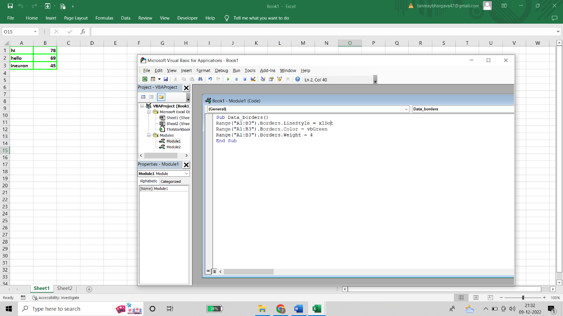

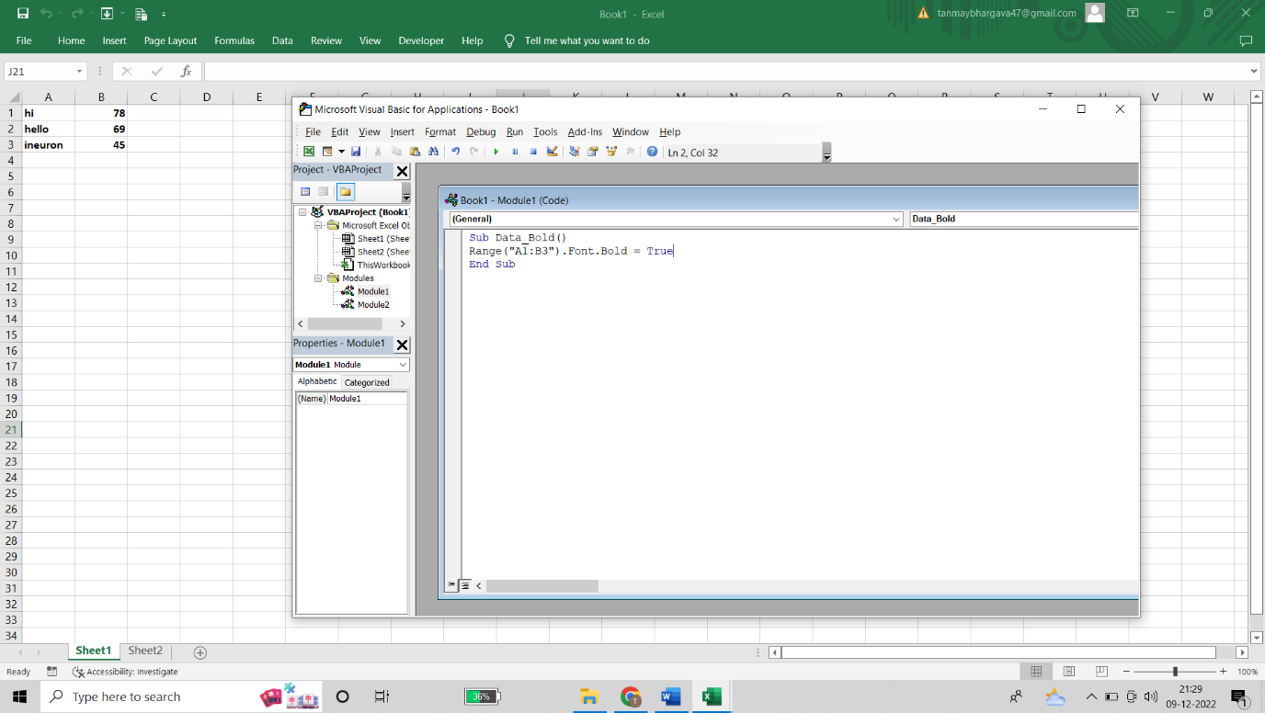

1. **VBA Editor** is the platform to write and edit the VBA code. By default, it is hidden. To use it, we need to activate it. Visual Basic Editor (VBE) is a separate application for Microsoft products like Excel, Word, and PowerPoint.
2. The Visual Basic Editor provides a place to write, run, debug, and store VBA code. The Visual Basic Editor is embedded into applications that support VBA and does not need to be separately downloaded or installed.

The **Properties window**displays the properties for the current object. When you select different objects in your VBA project, the Properties window changes to show just the properties of the object you selected.

The **Watch Window** makes it convenient to inspect, audit, or confirm formula calculations and results in large worksheets. By using the Watch Window, you don't need to repeatedly scroll or go to different parts of your worksheet. This toolbar can be moved or docked like any other toolbar.

**To navigate the Properties window**

1. From the **View** menu of the Visual Basic Editor, choose Properties window (F4).
2. Select the object whose properties you want to display. You can either use the mouse to select the object or use the **Project Explorer** to choose from a list.
3. Click the **Alphabetic** tab to display properties in alphabetic order, or choose the **Categorized** tab to display object properties by category.

**To add a watch expression**

* On the [**Debug**](https://learn.microsoft.com/en-us/office/vba/language/reference/user-interface-help/debug-menu) menu, choose **Add Watch**. The [**Add Watch**](https://learn.microsoft.com/en-us/office/vba/language/reference/user-interface-help/add-watch-dialog-box) dialog box is displayed.
* If an [expression](https://learn.microsoft.com/en-us/office/vba/language/glossary/vbe-glossary#expression) is already selected in the [Code window](https://learn.microsoft.com/en-us/office/vba/language/reference/user-interface-help/code-window), it is automatically displayed in the **Expression** box. If no expression is displayed, enter the expression you want to evaluate. The expression can be a [variable](https://learn.microsoft.com/en-us/office/vba/language/glossary/vbe-glossary#variable), a [property](https://learn.microsoft.com/en-us/office/vba/language/glossary/vbe-glossary#property), a function call, or any other valid expression.
* Select a [module](https://learn.microsoft.com/en-us/office/vba/language/glossary/vbe-glossary#module) or [procedure](https://learn.microsoft.com/en-us/office/vba/language/glossary/vbe-glossary#procedure) context in the **Context** group to select the range for which the expression will be evaluated.

1. To display the **Immediate** window, open a project for editing, and then choose **Debug > Windows > Immediate**or press **Ctrl+Alt+I.** You can also enter **Debug. Immediate** in the **Command** window. The **Immediate**window supports IntelliSense. **Immediate** window to debug and evaluate expressions, execute statements, and print variable values. The **Immediate** window evaluates expressions by building and using the currently selected project.